**Assignment 6**

* **Problem statement:** Upload a static website on S3
* **Steps:**

1. After sign in AWS account go S3

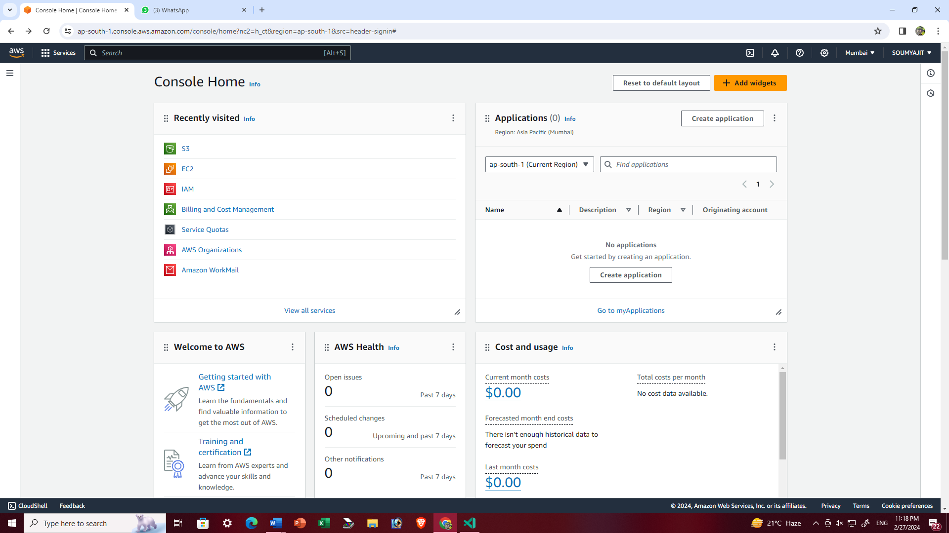

1. Open “nathbucket1” bucket which is previously created

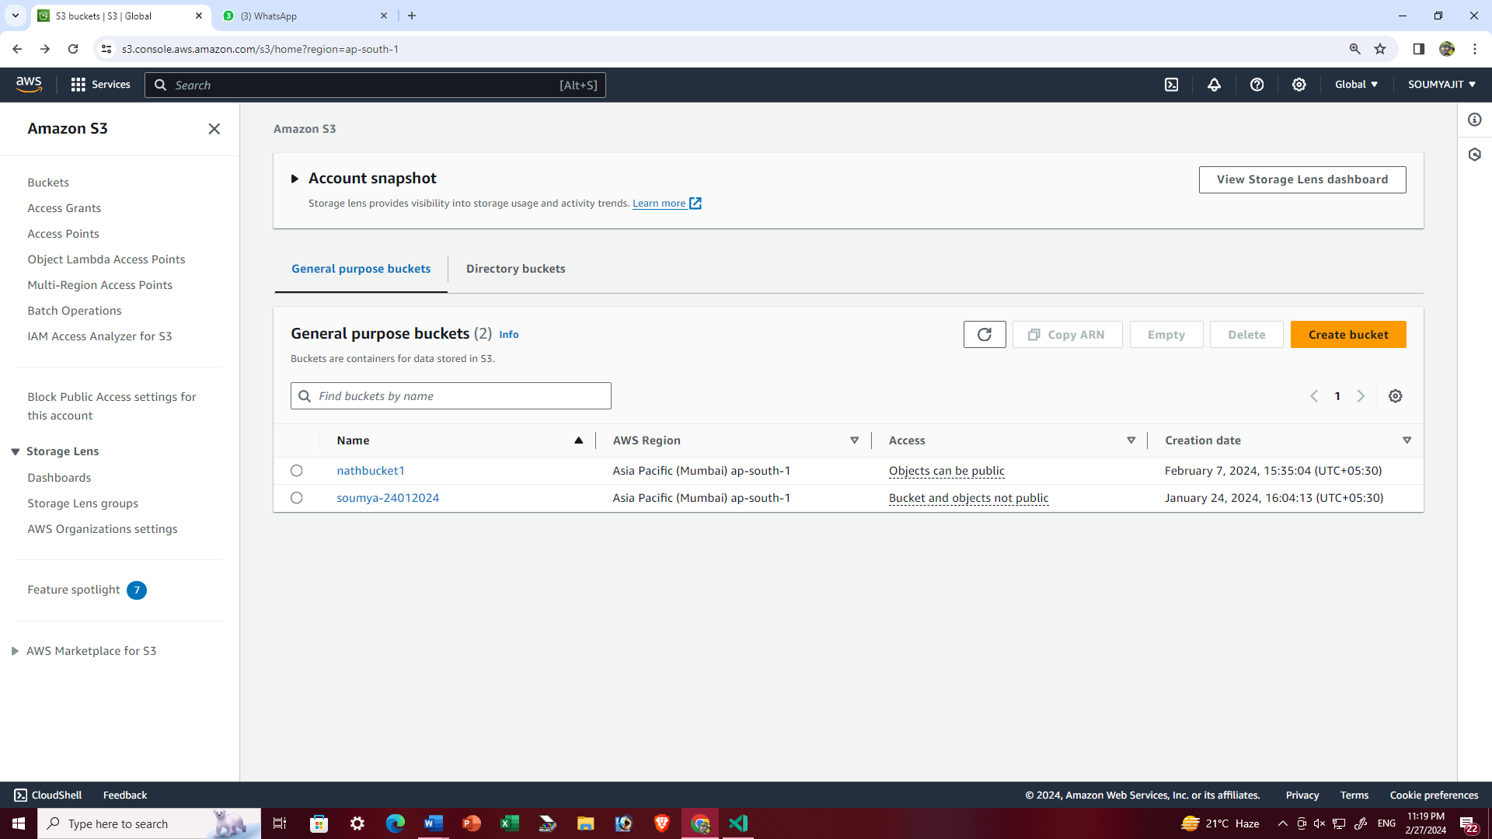

1. Click on ‘Upload” for upload all the web page file separately

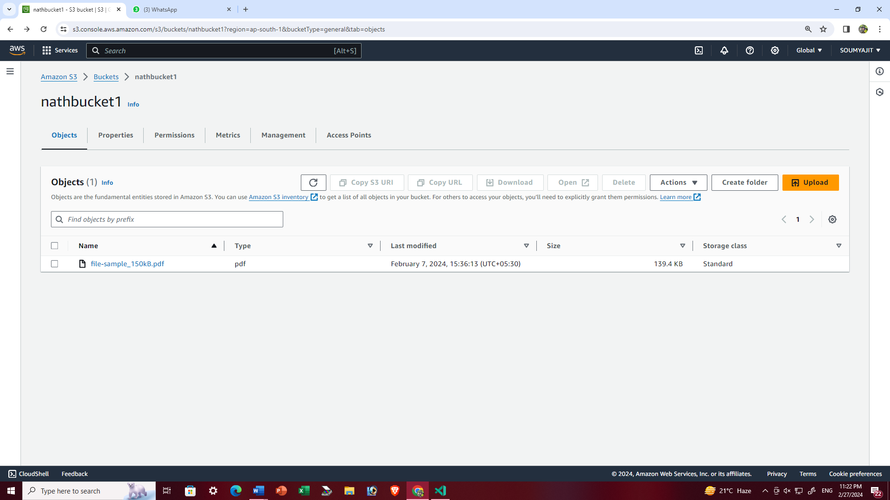

1. Add all the files and then click ‘Upload’

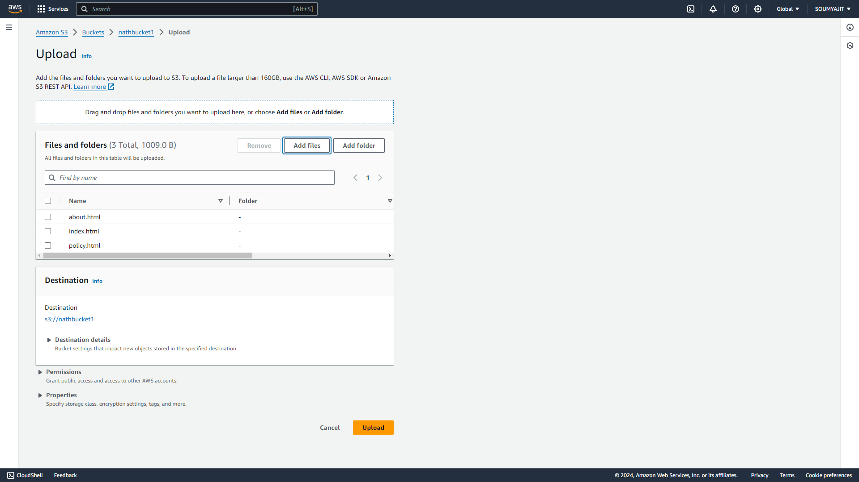

1. Upload successfully

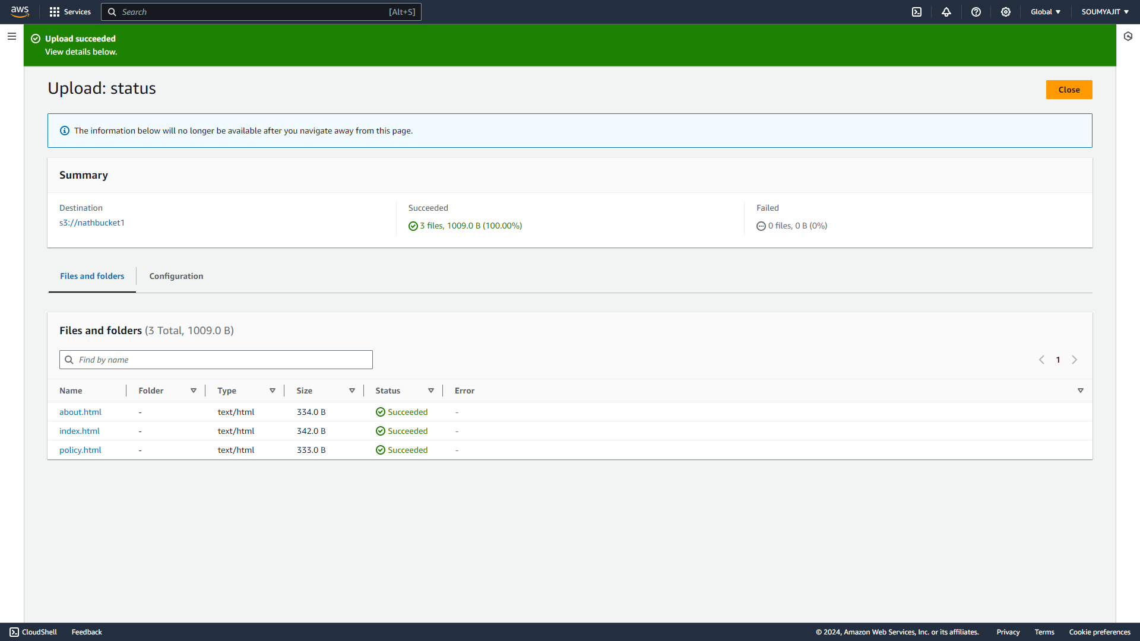

1. Click ‘Close’ and come back to the bucket page and click on the ‘properties’ and go to the ’static website hosting’ option and click on ‘Edit’

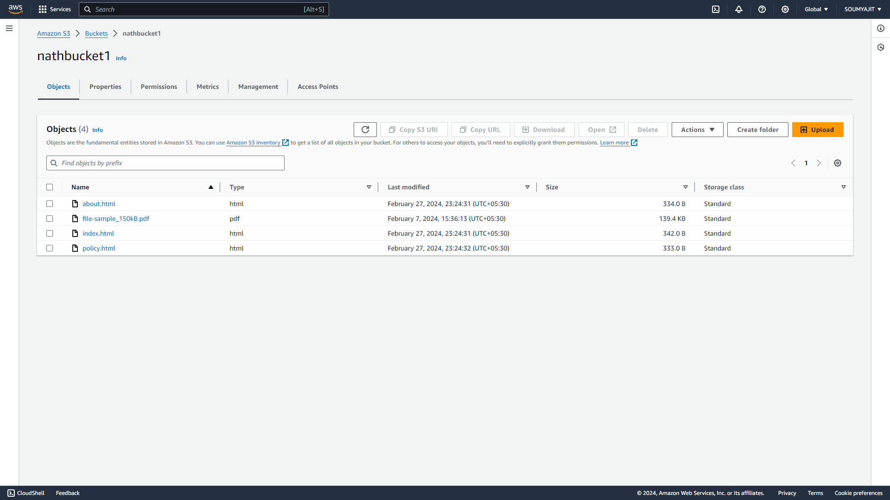

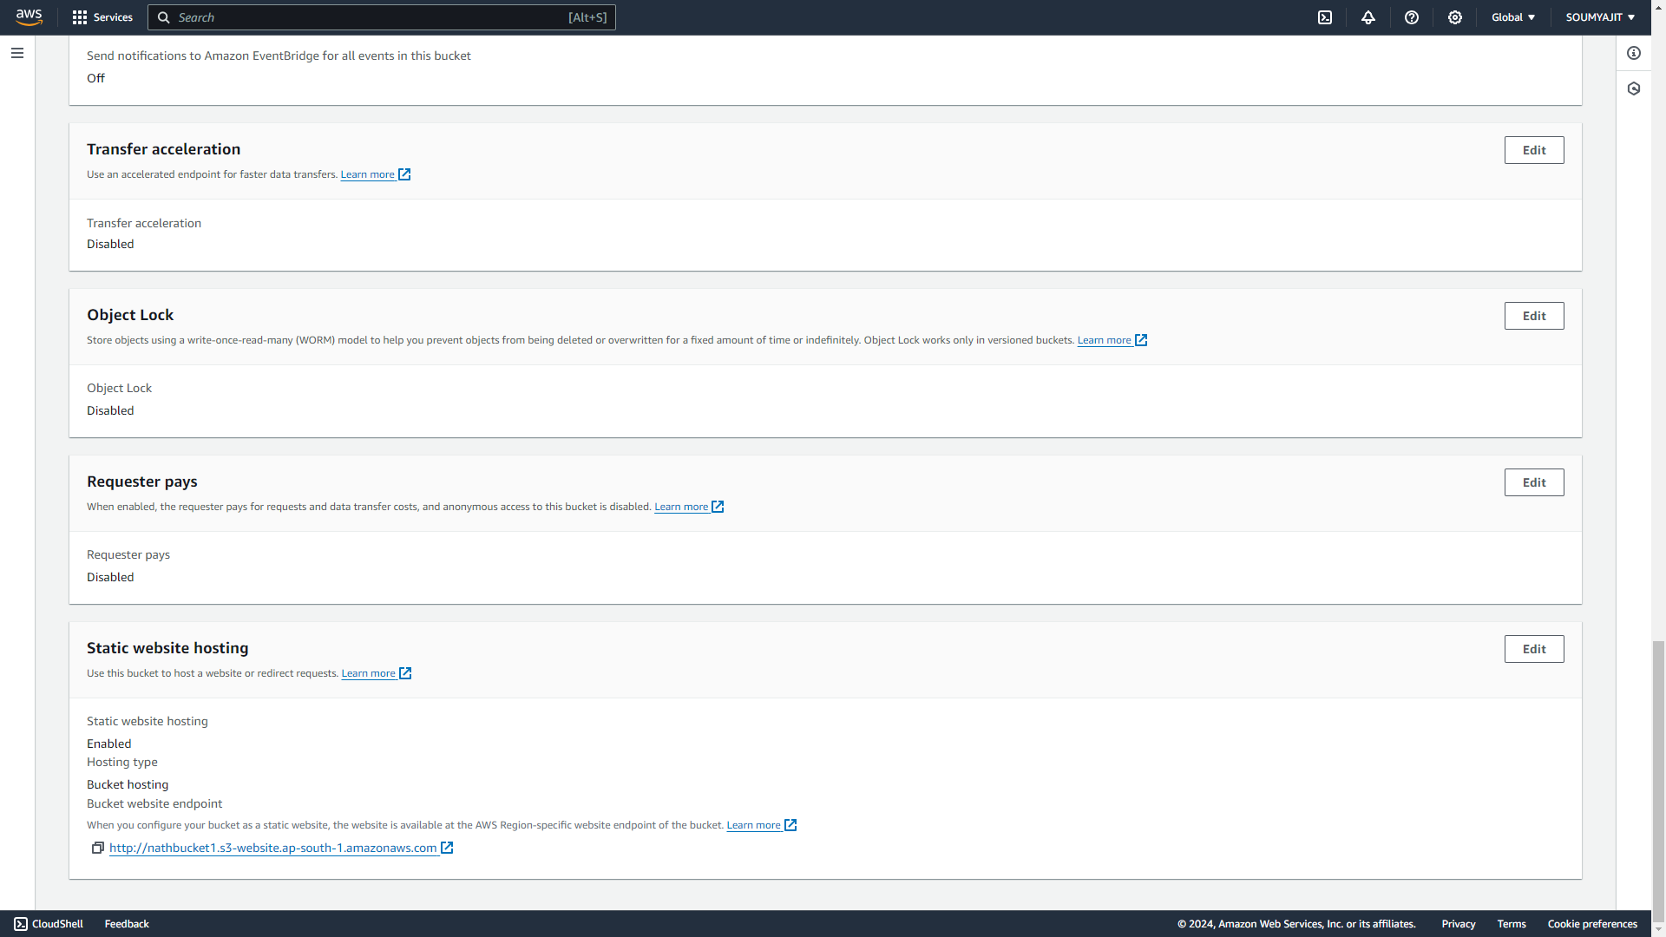

1. Click on ‘Enable’ the button do the other process mentioned in the picture and ‘save changes’

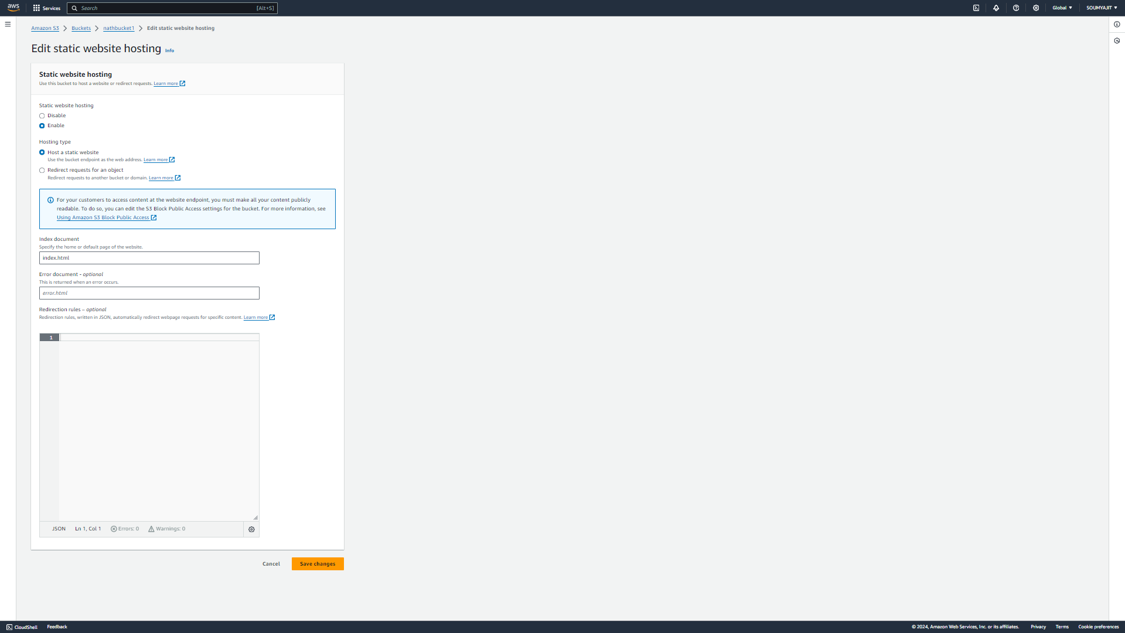

1. Then come to the bucket Click on the index page file and copy the object URL

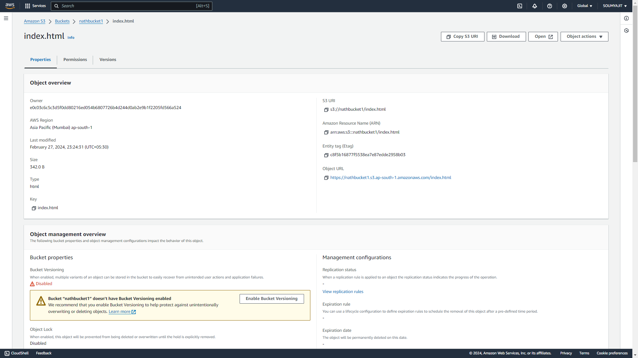

1. Paste it on new incognito

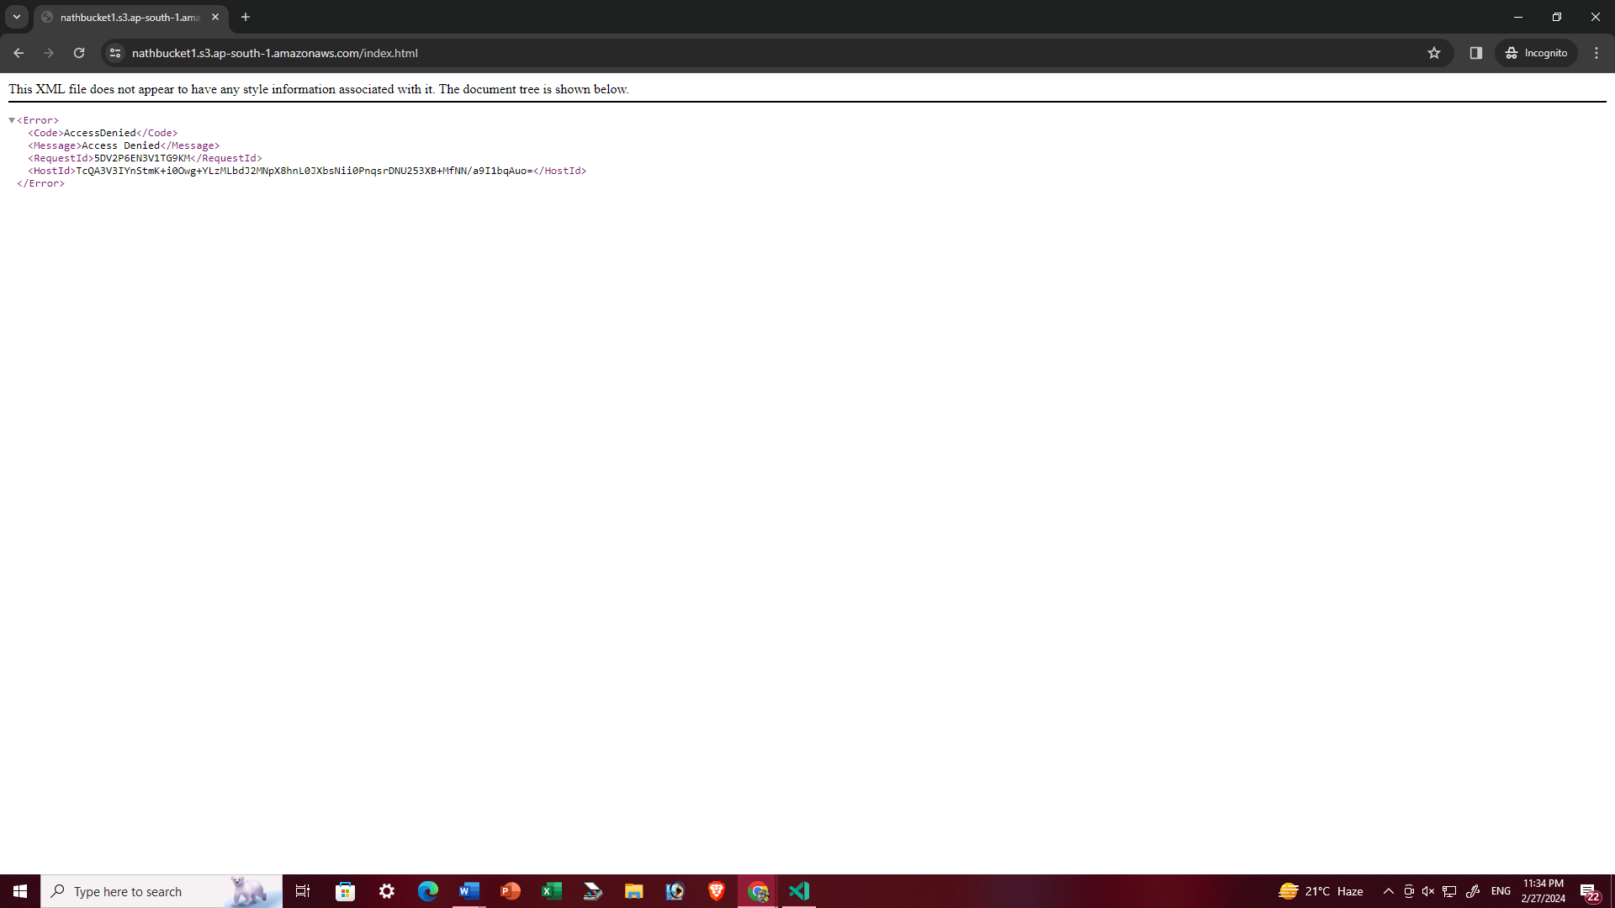

It will show that the page is not access able

1. Again come back to the previous page of the AWS and click on the ‘permission’ and click ‘edit’

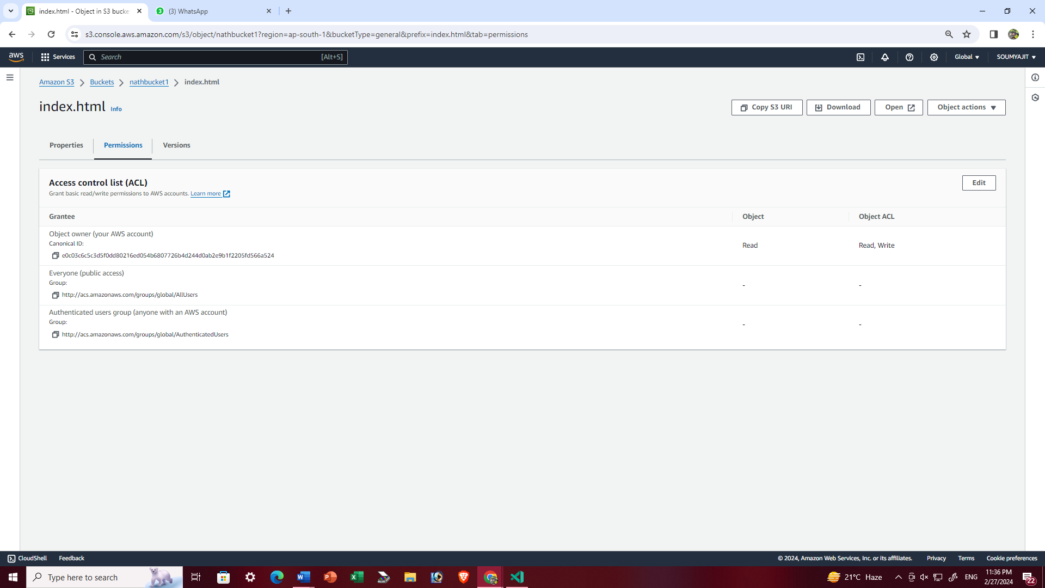

1. Check the boxes which is shown in the picture and click ‘save changes’

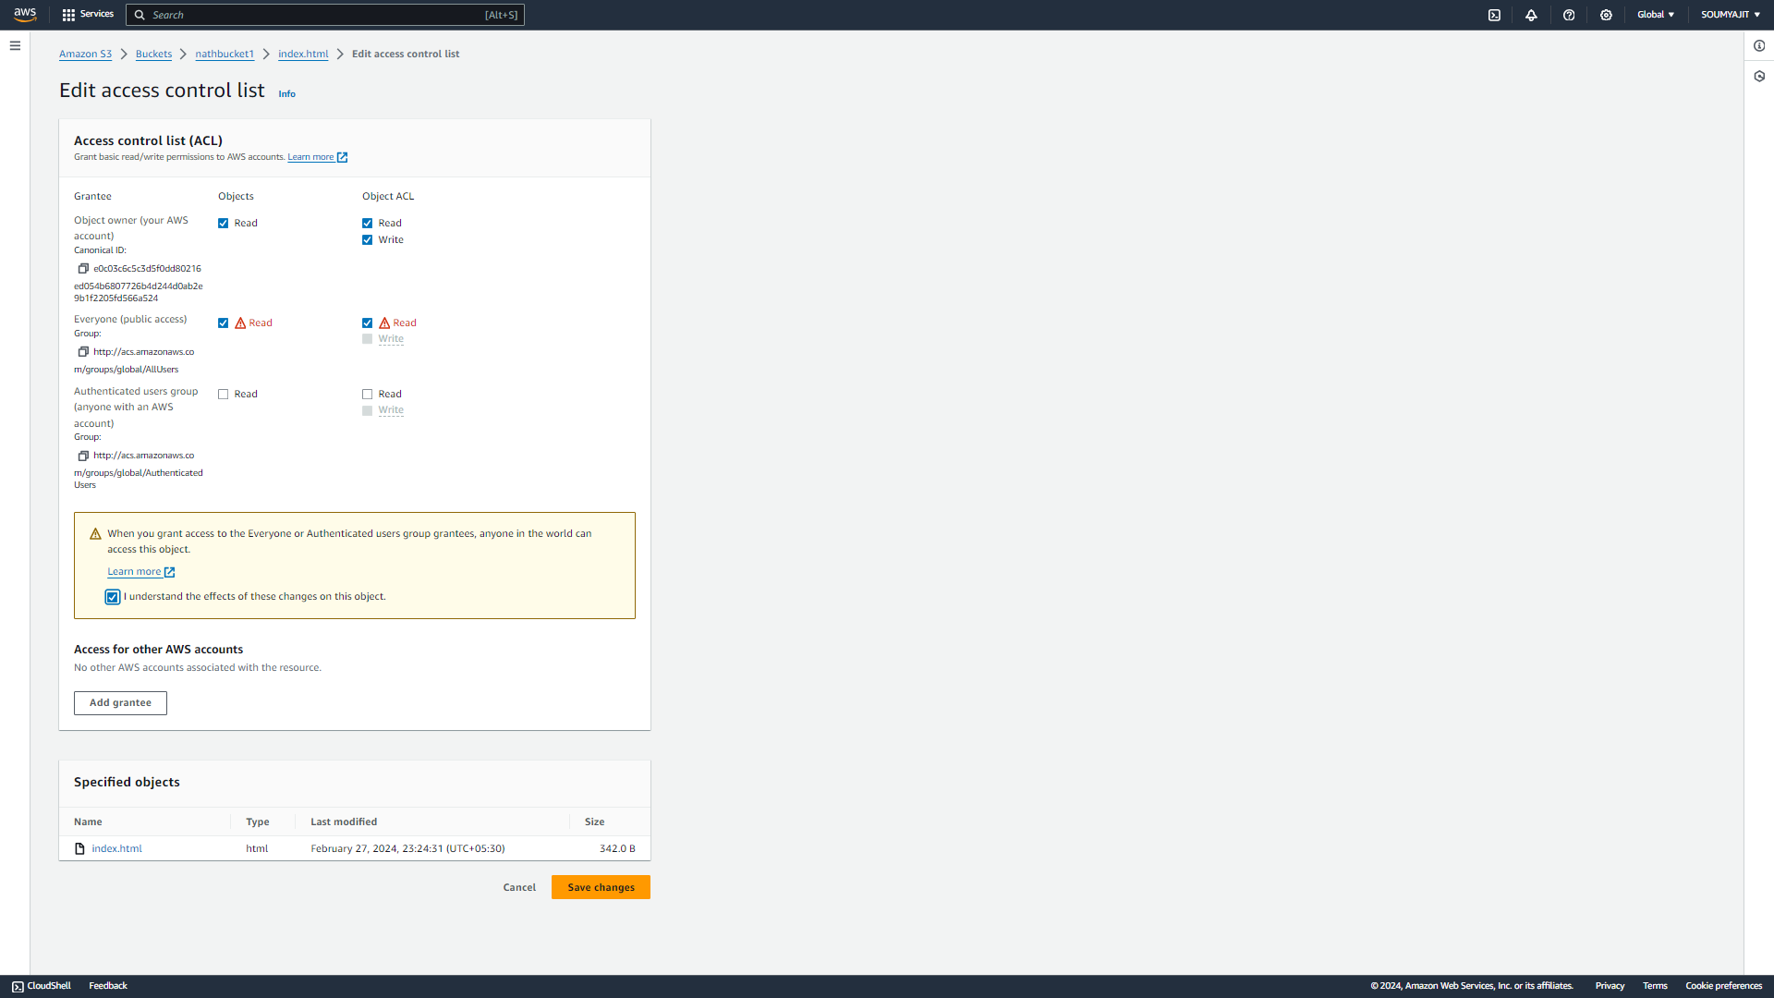

1. Again copy the URL and paste it on incognito

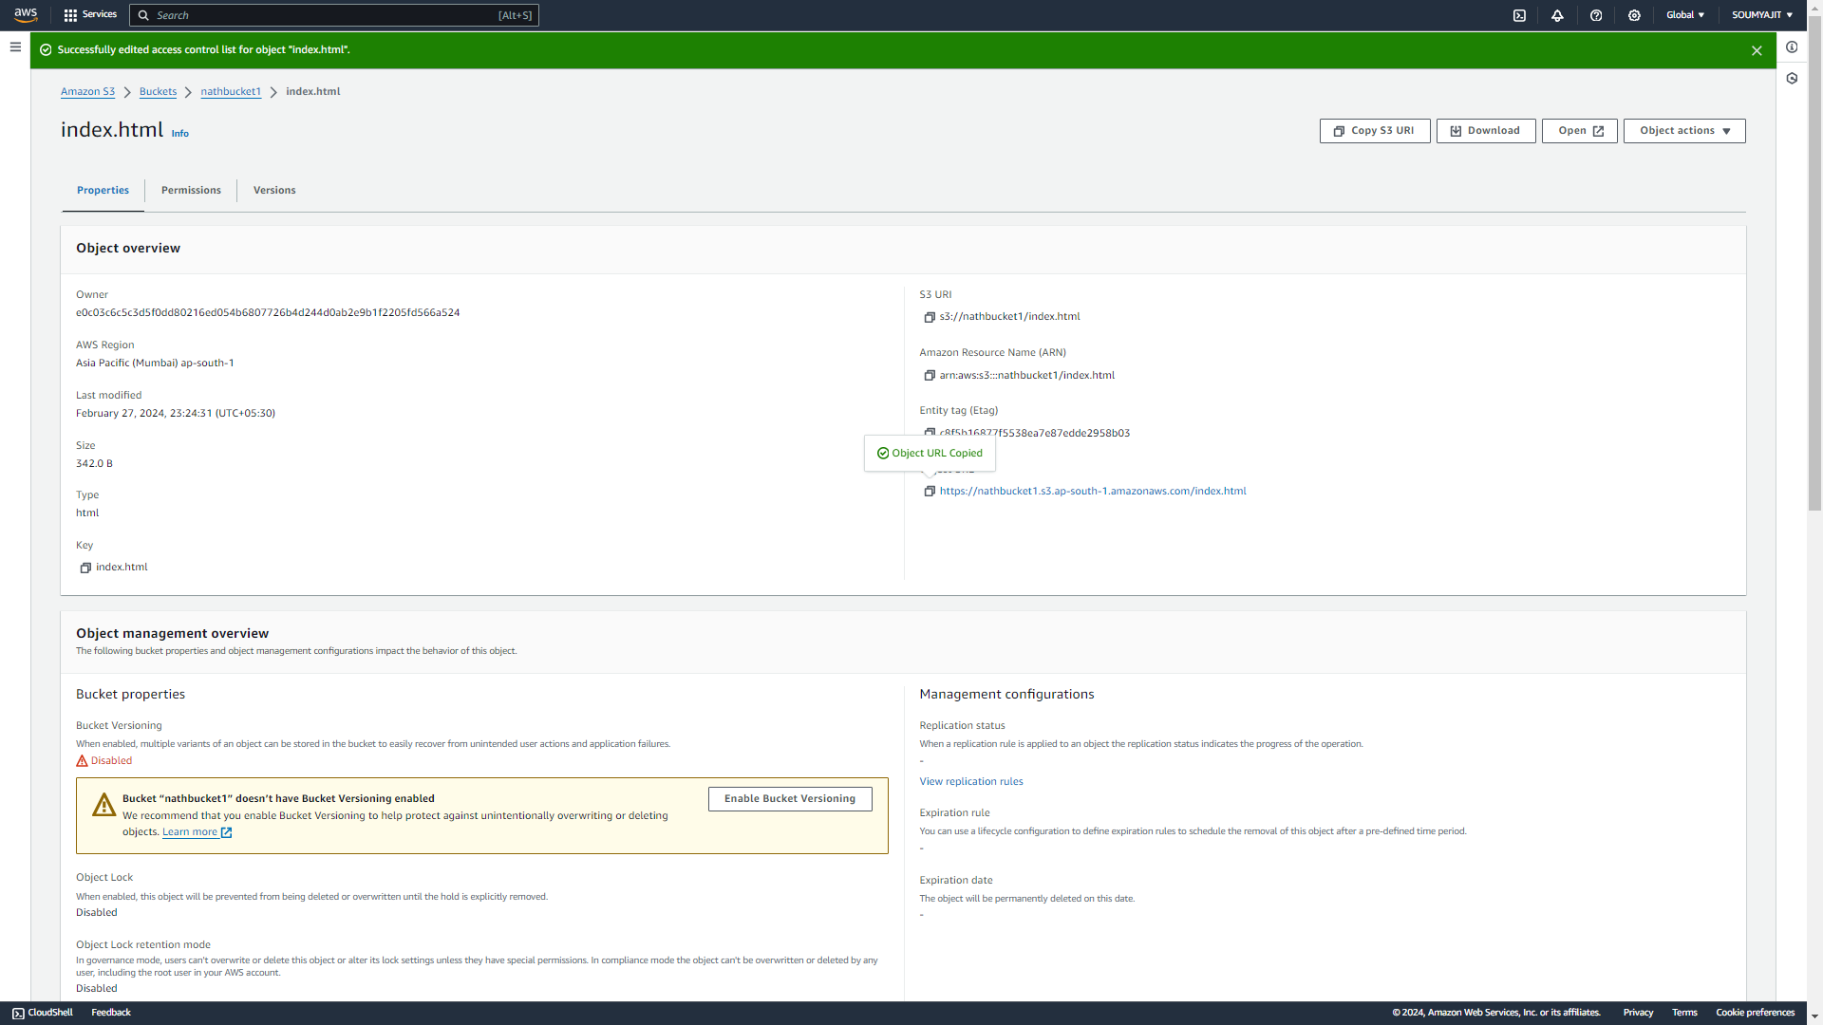

It is shows that now the index page is access able

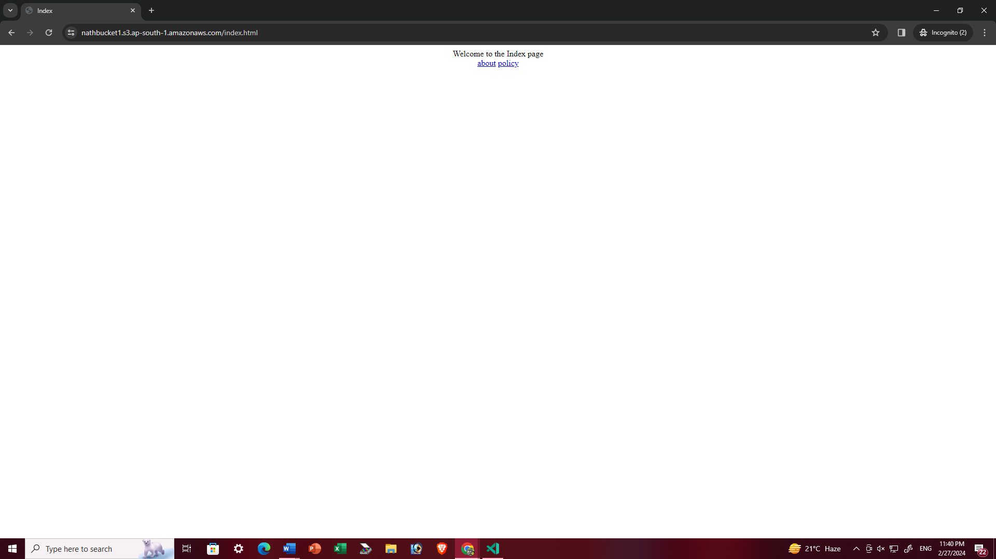

But if we try to access h2 or h3 it will give the error

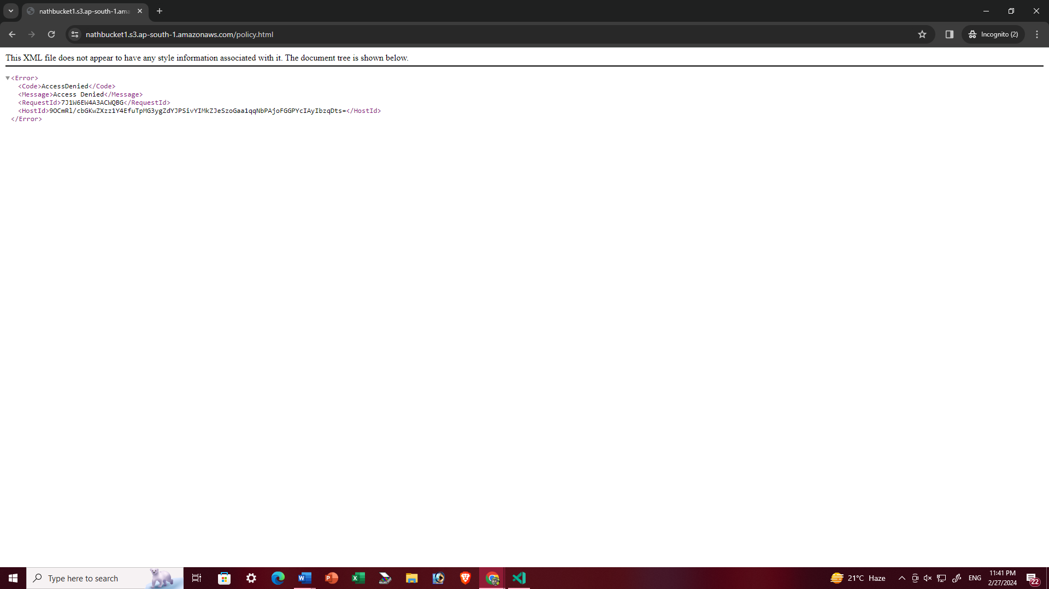

Because we on give the permission of the index page only so this permission is not applicable for the others web page. So for access all the pages we need to give the permission separately

Now we have another way to give the permission access all the pages at once

1. Remove all the files from the bucket and again upload all the files but before click ‘upload’ option go to the ‘permission’ option and enable ‘get the public read access’ option and then click ‘upload’

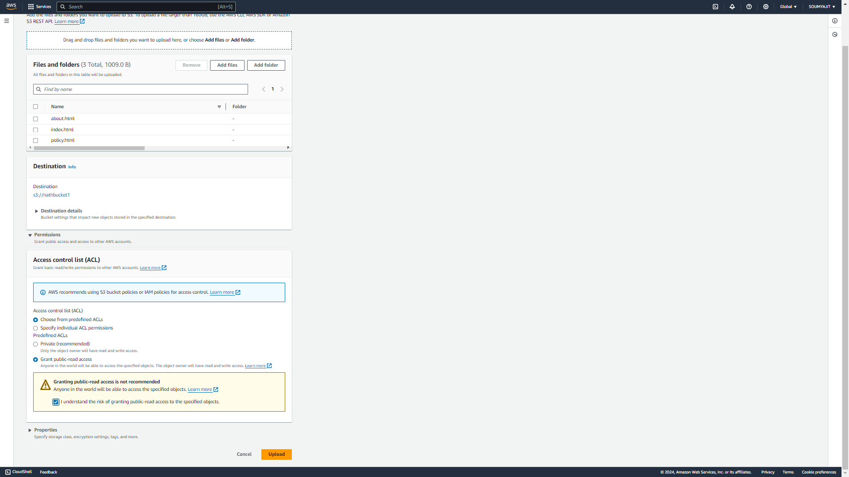

1. Upload successfully

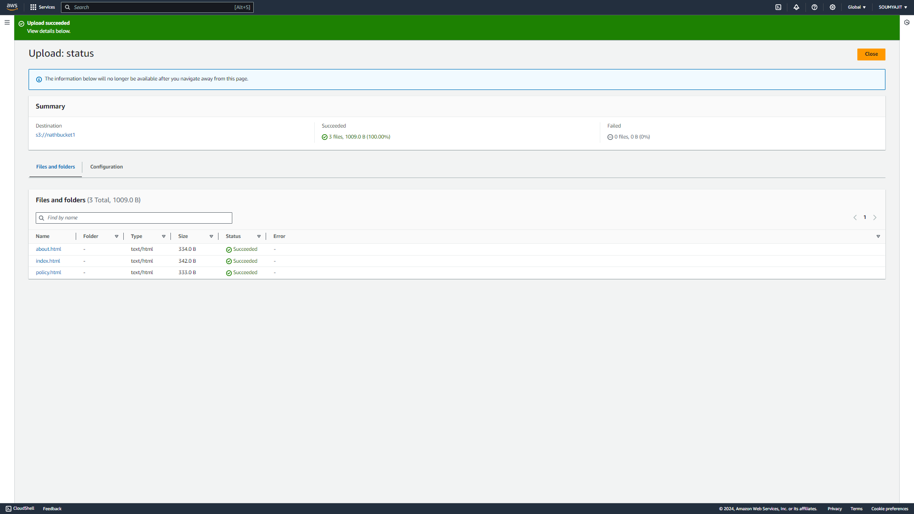

1. Click ‘Close’ and come back to the bucket page and click on the ‘index.html’ file

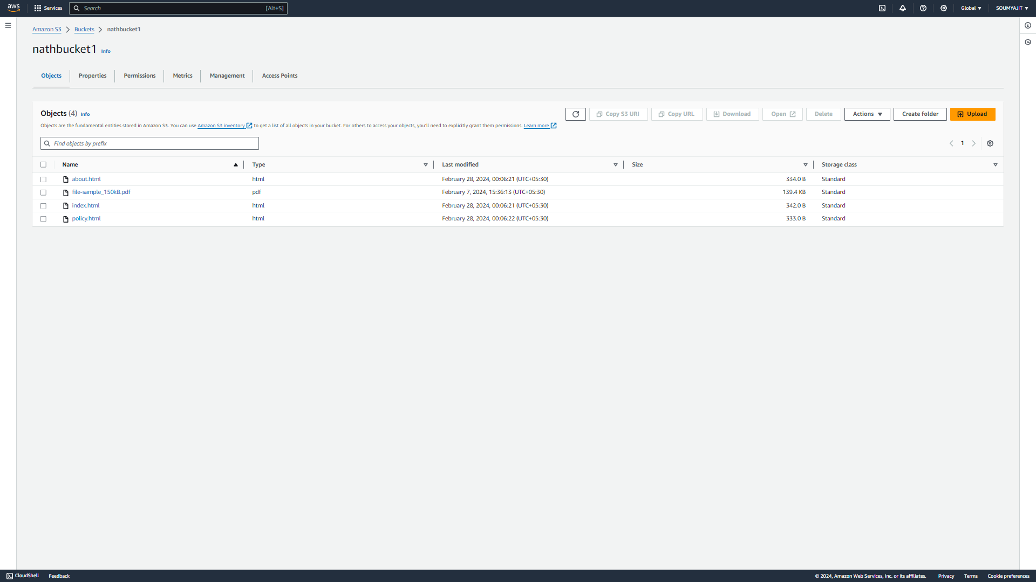

1. copy the object URL

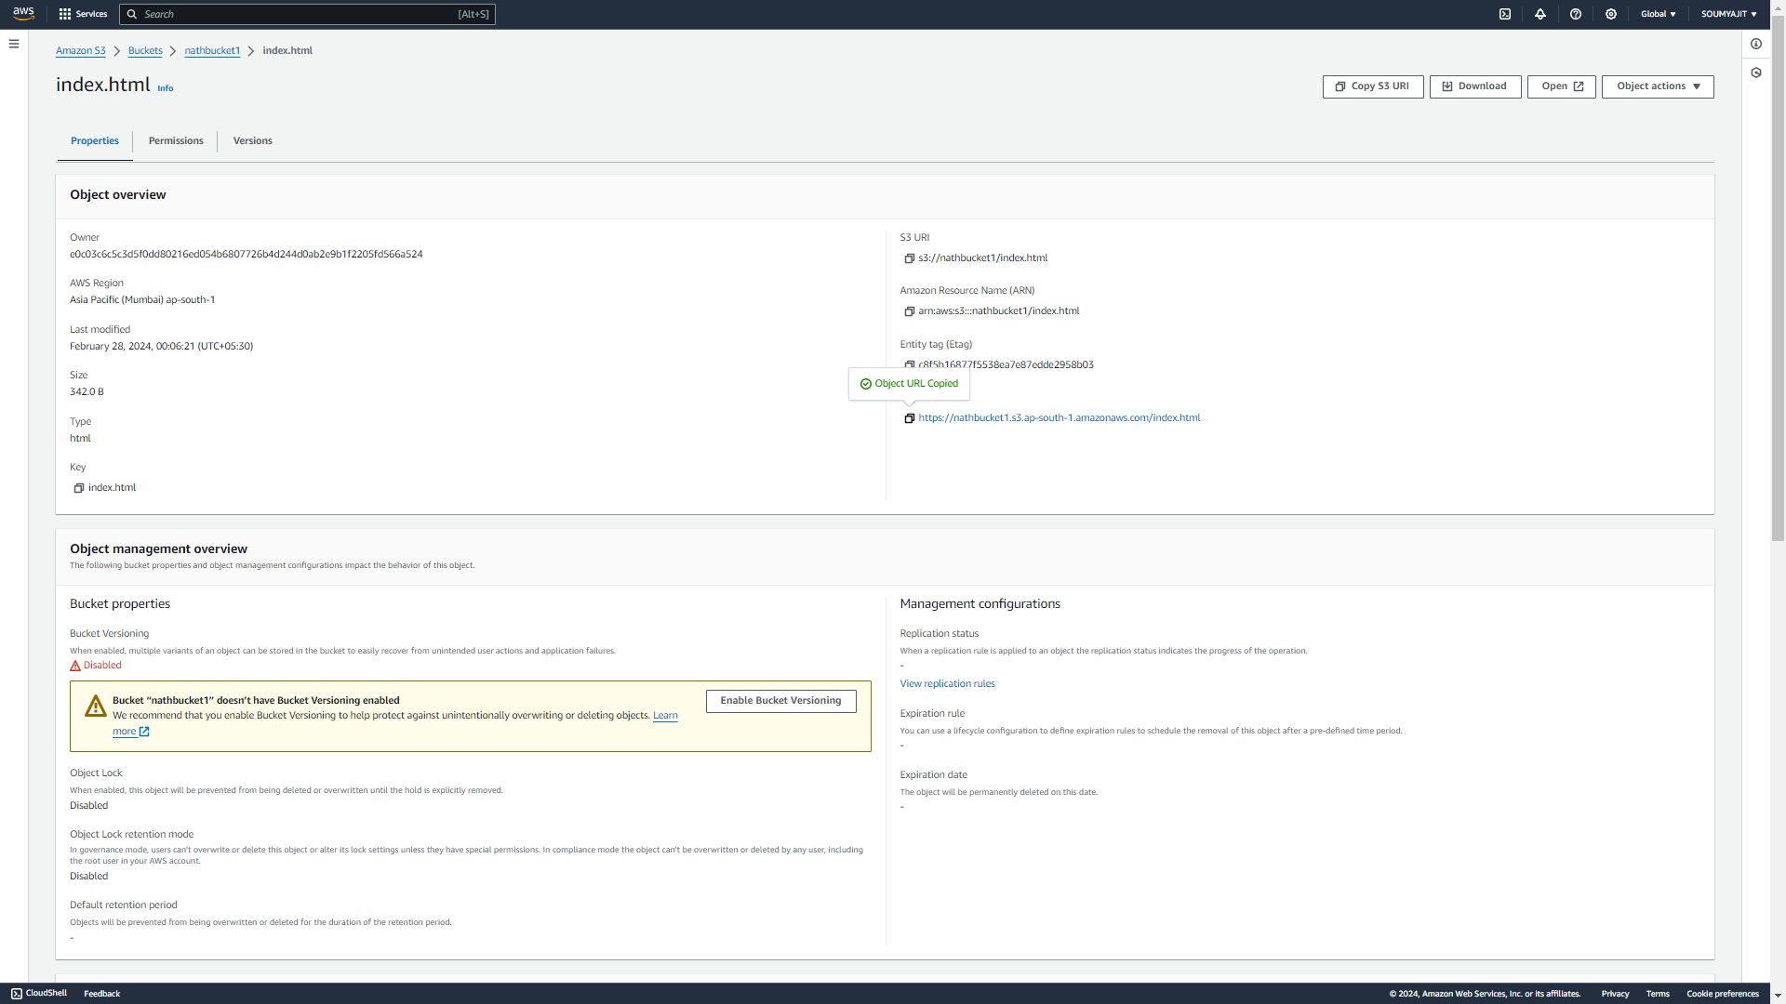

1. paste it in incognito

now Index page is access successfully as well as

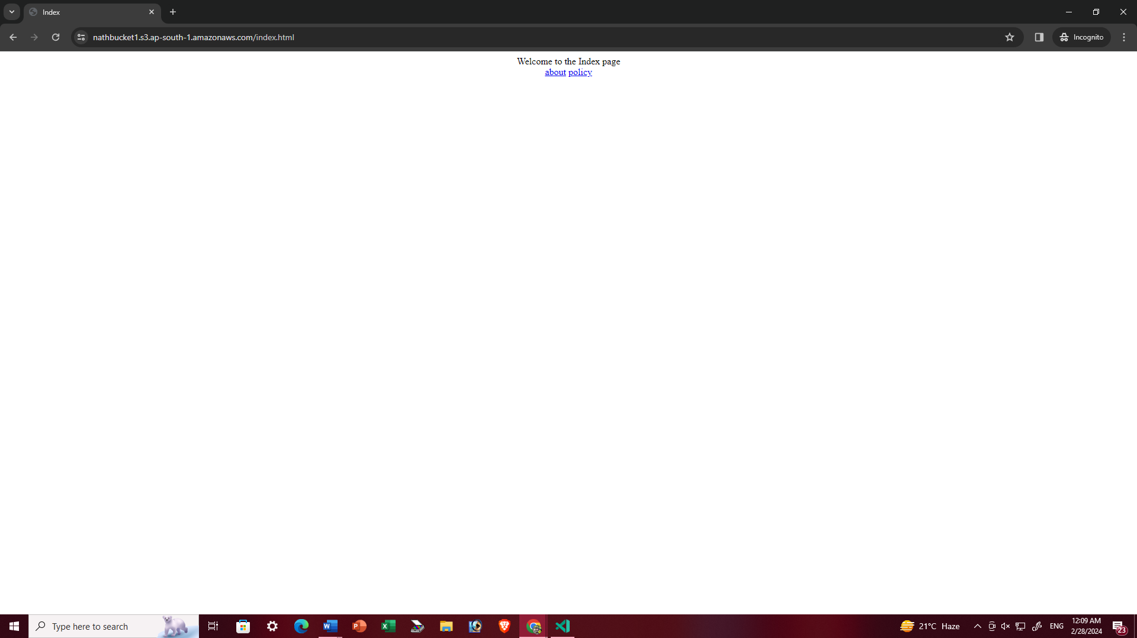

about page is also can access from index page

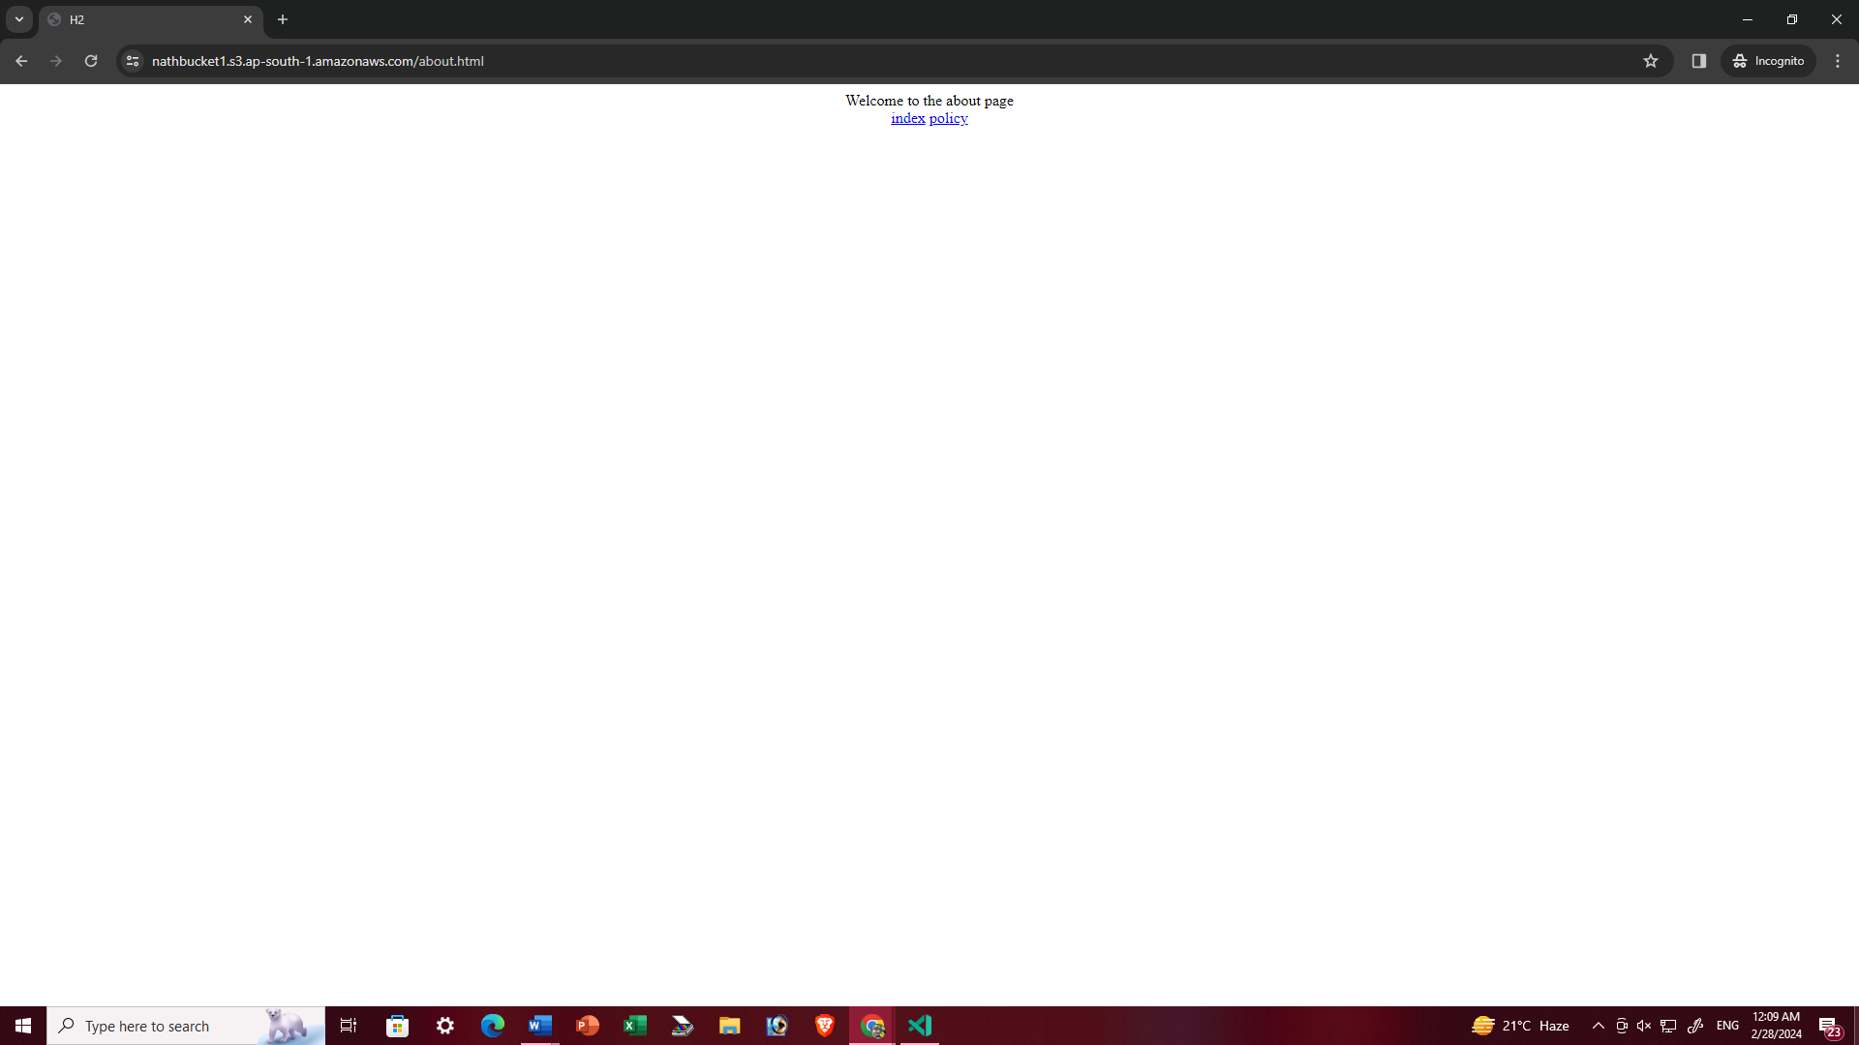

policy page is also can access from index page

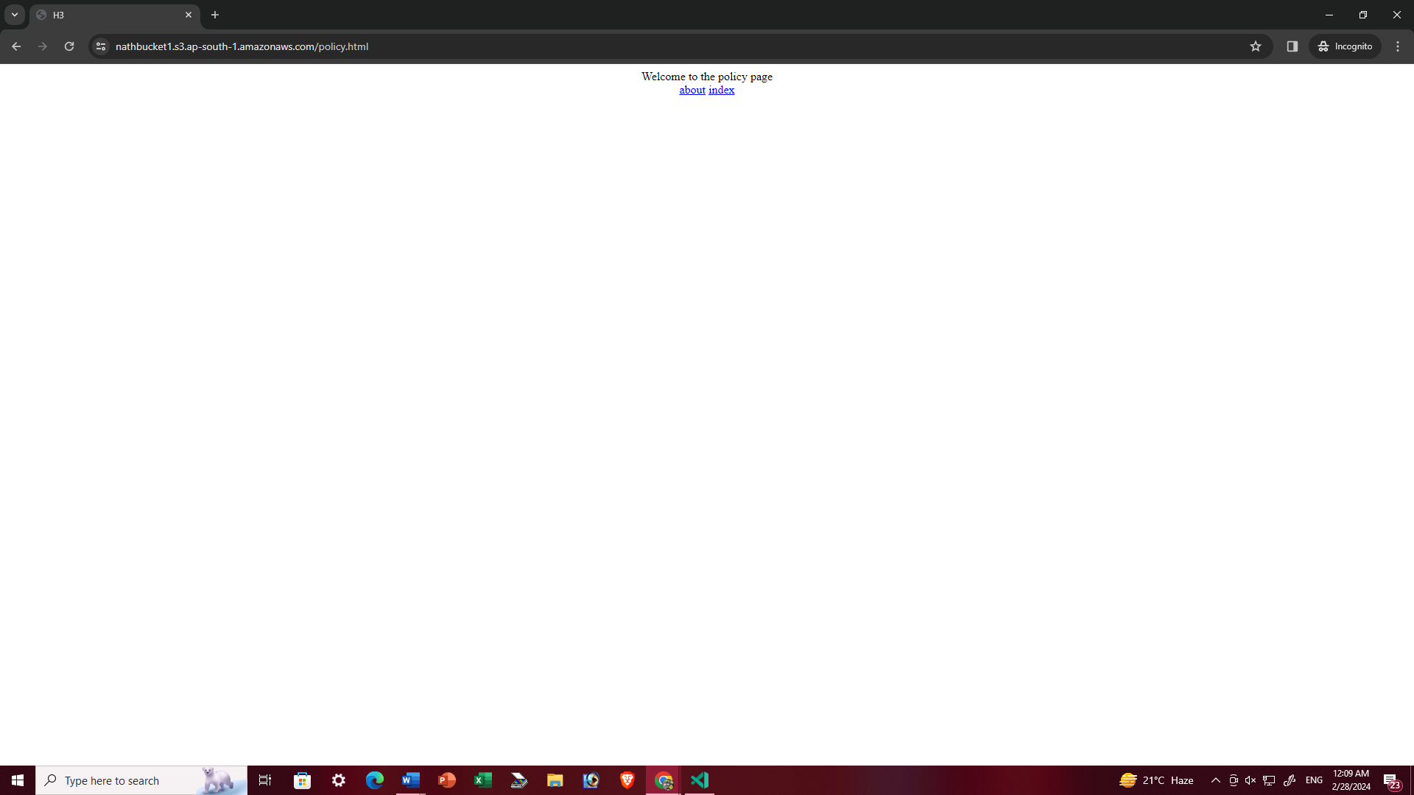

Here all three pages are inter connected with the index page that’s why we can access the pages from index page